Invitation
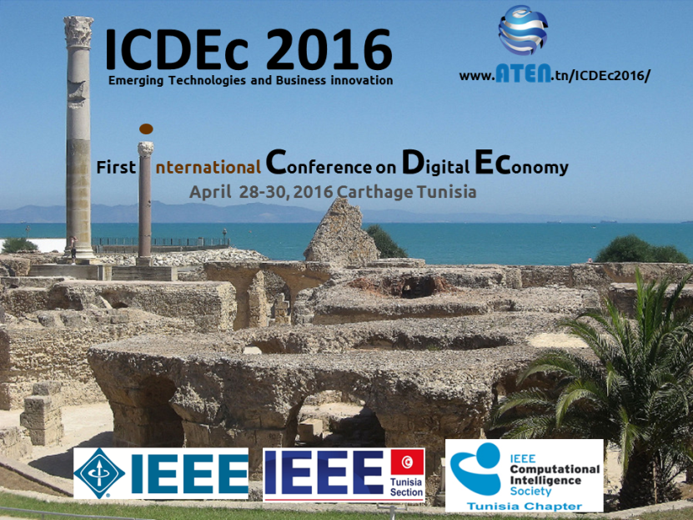
www.aten.tn/ICDEc2016
On behalf of the Tunisian Association of Digital Economy ATEN and the Higher School of Digital Economy ESEN - University of Manouba- Tunisia, we are writing to invite you to “The first edition of the International Conference on Digital Economy – ICDEc 2016” to be held from April 28 to 30, 2016, in Carthage, Tunisia.
The theme of the ICDEc- 2016 is
“Digital Economy: Emerging Technologies and Business Innovation” The conference is technically co-sponsored by IEEE Tunisia Section and IEEE CIS Tunisia chapter. The Purpose of the conference is to promote innovative research that highlights the impact of emerging technologies of the digital economy, with in particular, the role of “Cloud computing, Big Data, and Mobile Technologies” on business innovation.
Looking forward to welcoming you in ICDEc Carthage,
Sincerely,
Rim Jallouli Chaâbouni
Invitation
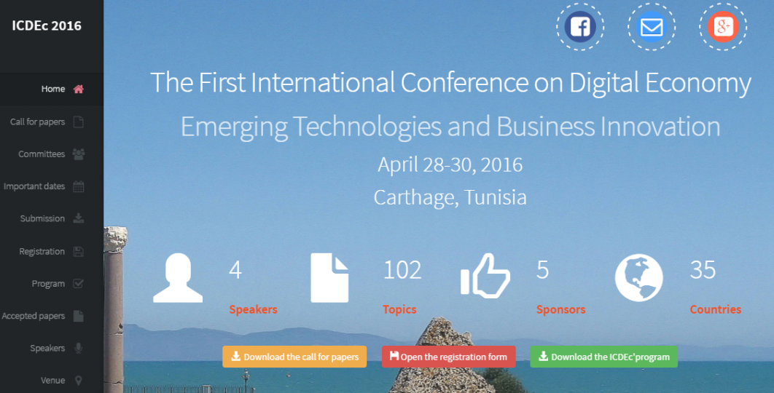
General Co-Chairs
- Rim Jallouli Chaâbouni, President and Founder - The Tunisian Association of Digital Economy ATEN, Dean -The Higher School of Digital economy ESEN, University of Manouba, Tunisia
- Olfa Nasraoui, Director- Knowledge Discovery & Web Mining Lab, Univ. of Louisville, IEEE CIS senior member, University of Louisville, USA
Keynote Speakers:
- Prof. A. Alimi : The founder and director of the REGIM-Lab. on intelligent Machines, Univ. of Sfax Tunisia
- Prof. O. Zaiane: Scientific Director, Alberta Innovates Centre for Machine Learning AICML, Univ. of Alberta Canada
- Prof. Olfa Nasraoui : Director, Knowledge Discovery & Web Mining Lab, Univ. of Louisville
- Prof. Serge Miranda : Univ. de Nice Sophia Antipolis, France
Invitation

